13 Steps to Powerful Youth Pitching Mechanics

Learn how to develop high velocity pitching mechanics and better control while reducing stress to the arm
http://www.youthpitching.com/mechanics.html#starting-stance

If you want to learn about proper pitching mechanics for baseball in step-by-step detail, you're going to love this article.
Let's face it:
As parents, we all want our son to succeed on the pitcher's mound.
We also know that his success depends largely on his ability to have good control so that he is able to throw strikes and get hitters out.
Here's the deal:
If pitchers can't throw strikes, they won't get much of an opportunity to pitch.
Plus, it's not much fun pitching when you're walking everybody.
But there's more:
Besides having good control, pitchers also need to be able to throw hard and stay healthy.
So, what's the secret to throwing strikes with good velocity while preventing injuries?
Proper pitching mechanics.
A solid understanding of quality baseball pitching mechanics and how the body works can help maximize performance and minimize the risk of arm problems.

Basic and efficient pitching mechanics
Pitching a baseball is one of the most dynamic skills in all of sports.
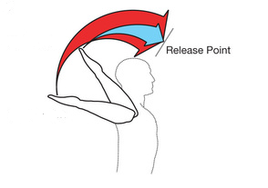
During a pitch, shoulder internal rotation velocity reaches an incredible 7500±900°/s, making it the fastest human motion in any athletic activity.
Yet as highly skilled as pitching a baseball is, it's also highly individualized—clearly, not all successful pitchers throw exactly alike.
In fact, a pitcher's motion depends on many things such as his size, strength, balance, flexibility, leverage and coordination.
When teaching pitching mechanics or providing private pitching lessons, a coach should try to work within a pitcher’s own style, physical abilities, limitations and potential.
If a pitcher is successful, I encourage you to let him use his natural delivery unless:
- His mechanics create unnecessary stress or fatigue on the arm and are likely to cause an injury.
- His motion causes inconsistent control or inconsistent performance.
- His techniques limit his pitching potential.

Biomechanics of baseball pitching
Although pitching is a continuous motion that takes approximately 2 seconds, the biomechanics of the delivery can be separated into a series of phases to better understand, evaluate and analyze the movement patterns in the kinetic chain.
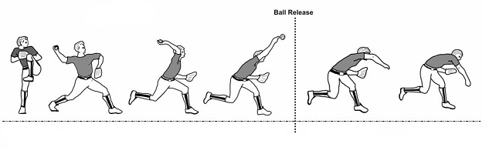
The following breakdown of the pitching motion into 13 steps is meant to be a guide for the parent who is instructing a young pitcher...
...or the coach who is attempting to make adjustments for a pitcher who is experiencing specific problems within his motion.

Sequence of body movements in the pitching motion
Phases
1. Starting stance
2. Wind up (Rocker step → Pivot)
3. Leg lift (Forward rock → Knee up)
4. Maximum knee height
5. Stride
6. Stride foot contact
7. Arm cocking
8. Maximum external rotation
9. Arm acceleration
10. Release
11. Arm deceleration
12. Maximum internal rotation
13. Follow-through

Step 1: Starting stance
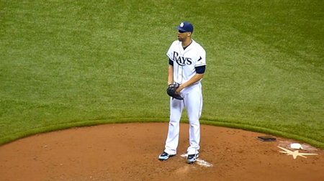
In the starting stance, a pitcher should have good balance and keep his shoulders relaxed and body squared off to the plate.
The spikes of the pivot foot (pitching arm side foot) should be in front of the rubber and slightly open. The free foot (glove side foot) should be next to or slightly behind the pivot foot and about shoulder width apart.
Start with the hands comfortably at mid-chest or the belt. The pitching hand and wrist should be held deep inside the glove, hiding the grip and ball from the batter and coaches.
- Many pitchers have problems gripping the baseball properly due to lack of hand size, finger length or grip strength. Read this article to learn 13 different pitching grips young pitchers can use to be successful.
Lastly, a pitcher should keep his eyes fixed on the target to get the sign from the catcher. Stand tall, feel relaxed and take a deep breath.

Steven's pro tip
I'm often asked, "Which side of the rubber should a pitcher stand on?" If a pitcher throws right handed, I generally want him on the right side of the rubber. And if he is left handed, he should be on the left side. This position helps the pitcher stride in a straight line to home plate and also improves the angle of a breaking pitch from a RHP to a RHH, or a LHP to a LHH.

Step 2: Wind up
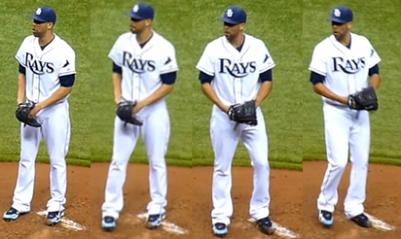
Once the pitcher gets his sign from the catcher in the starting stance, he needs to initiate the pitching delivery with a simultaneous hand pump androcker step.

Hand pump
For the hand pump, a pitcher may choose to lift his hands over his head, over and behind his head, only to his chest, or keep his hands still.
If a pitcher has balance or coordination problems, he should lift his hands only to his chest or keep his hands still. Less movement means fewer things can go wrong.

Rocker step
The rocker step is a small transfer of weight from the pivot foot (pitching arm side foot) to the free foot (glove side foot). This movement helps the pitcher shift his weight back briefly in order to put muscles on stretch to move forward, and should develop rhythm and tempo right from the start of the motion.
The rocker step should be a short step of no more than 3-6 inches straight back, at a 45° angle, or a 90° angle to the side.
While David Price steps directly to the side, most pitchers step back at a 45° angle rather than straight back because it makes it easier to position the lead foot in front of the rubber during the pivot.
However, I recommend you use the step back approach rather than stepping to the side. Stepping straight back allows the pitcher to keep his body in-line with the target while also building more momentum and thus create more potential velocity.
Regardless of which rocker step method is used, the biggest problem that most pitchers will have is not hesitating during the step back.
Keep the head in the center of the body—directly over the pivot foot—to stay balanced.

Pivot
Following the rocker step, the body begins a squaring off maneuver called thepivot, during which the pivot foot is placed in a parallel position along the front edge of the rubber.
- Many pitchers have problems moon walking from one side of the rubber to the other during the rocker step and pivot because they take too big step of a step to the side. Remember to take a small rocker step of no more than 3-6 inches preferably straight back to eliminate unnecessary movements and keep the head directly over the pivot foot.
Remember, a RHP should pitch from the right half of the rubber, a LHP from the left half. Proper foot position on the rubber helps the effectiveness of various pitches by maximizing the angle of pitch approach to the hitter.

Steven's pro tip
During the rocker step and pivot, avoid any weight shift outside the midline. The midline is a line drawn from the middle of the back foot toward the target. Every time a pitcher moves his body away from midline, it requires another (extra) movement to get back along that same line, which disrupts timing and momentum.

Step 3: Leg lift
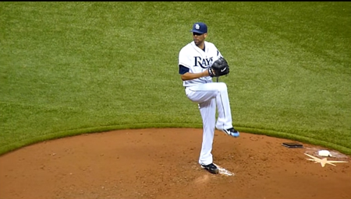
Once the pivot foot has been positioned, the pitcher is ready for a forward rock into the leg lift.
As the leg comes up, make sure the pitcher lifts with the knee and does not swing up the foot, which puts many pitchers out of balance.
The lift leg foot should hang freely straight down from the knee.
The front hip rotates closed to a 90° angle or more, while keeping the weight back over a fairly straight firm posting leg to maintain balance.

Steven's pro tip
Do not allow the body to drift forward until the lead leg knee reaches its maximum height, as described in the next step, and then starts to move downward into the stride.

Step 4: Maximum knee height
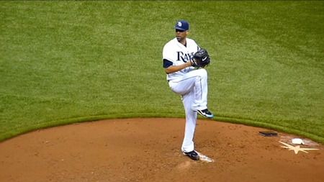
As the pitcher lifts his knee up to maximum height, I recommend stopping the thigh slightly higher than parallel to the ground, but not so high that it causes a loss of balance.
The knee should also be angled back slightly over the rubber toward second base, which closes off the hips.
A good rule of thumb for most pitchers is that maximum knee height is somewhere between 60% and 70% of a pitcher's body height.
A pitcher may lift his lead leg knee up higher than 70% to the chest area if he can maintain good balance.
That's a BIG if, though.
Lifting the leg significantly higher than parallel requires it to come straight back down before it can move forward.
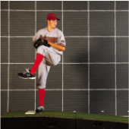
This extra movement increases the force required by the pitcher to move his body down mound as he starts to expand sideways along midline, and can prevent a pitcher from generating good forward momentum.
More times than not, a high leg lift does not improve velocity but only slows down forward momentum.
During the leg lift up and at the top, keep a firm back leg; the back leg must not collapse during leg lift, nor prior to the stride toward home plate.
Coiling the body during knee lift or over-rotating at maximum knee height slows the pitcher down as he must now reposition his body sideways before he starts his movement toward the plate.
Remember, pitching is a linear activity or sideways activity.

Steven's pro tip
Don't come to a "balance point." A 2004 study compared pitchers who used a balance point to those who did not and found that pitchers using a balance point had more head movement which resulted in lower velocity and decreased accuracy.
Having a balance point during the leg kick:
- Creates an un-athletic posture.
- Decreases quickness to the plate (decreased momentum = slower velocity).
- Slows delivery tempo (poor timing = decreased accuracy).

Step 5: Stride
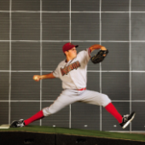
A 2013 study suggests approximately 50% of ball velocity in the pitching motion is the resultant forces accumulated in the stride.
Moving the body away from the rubber sideways and directing the entire pitcher's mass at the target has the single biggest influence on final pitch velocity.
Remember this:
In order to produce maximum velocity, a pitcher must move his body as fast as possible in a side lunge going from the back leg to the front leg without stopping or hesitating.
Stride length, therefore, is a good indication of how fast the pitcher is moving away from the rubber, as well as his ability to build forward momentum—both of which contribute greatly to pitching velocity.
Once maximum knee height is achieved, the pitcher will start to stride along the midline to the target. This initial movement, characterized by the body moving sideways at the target, has the single biggest influence on final pitch velocity.

Proper posture
Check the pitcher's posture: Is it upright?
Poor posture can restrict force production and add more stress on the arm; a pitcher who leans forward or backward will not direct his forces in the most efficient and effective manner at the target.
Good posture, however, allows the pitcher’s entire body mass to be directed toward the target.
To experience good and proper posture, a pitcher should stand with his heels, buttocks, and upper back against a wall while maintaining the natural curve in the back. The chin and nose should be positioned directly over the navel. The spinal alignment signals good posture and is what should be used in the delivery. It is important that through this brief but powerful movement toward the plate that the head, although turned to look at the target, be oriented directly above the body. That results in the trunk being positioned correctly to execute the next segment in the movement sequence and the accumulation of momentum begins with a very substantial contribution.
Proper posture is a great way to fix balance problems in young pitchers: When a pitcher understands what good body posture is and can maintain that along with keeping his head level, while moving faster, his balance problem will often disappear on its own.

Lead with the front hip
In other words, get the butt out.
As the stride leg lowers, the front hip should lead the movement toward home plate while the stride foot should move downward and slide just above the mound surface.
Sandy Koufax summed it up best when he once said:
Leading with the hip as long as possible and the back leg were two of his keys for pitching success.
The focus for Koufax was to use a strong back leg drive to get his body and front hip moving faster and further toward the plate while his back leg drive provided stability, direction and the driving force of the body toward the target.
As soon as the leg starts down maximum knee height, the pitcher should aggressively drive away from the rubber leading with his front hip.
As a way of getting pitchers to understand the timing of this, the late pitching instructor Dick Mills once said, pretend there is an invisible coach behind the pitcher and at the moment the leg starts down from maximum knee height, pretend that the invisible coach is forcefully pushing the pitcher from the back hip aggressively forward.
I like that mental image.
This also serves to get pitchers to understand that the front hip should lead the shoulder.
Think of the stride as a skater lunge to the side.
In order to produce maximum velocity, a pitcher must move his body faster lunging sideways from the back leg to the front leg without stopping or hesitating while keeping his head positioned over the center of the upper body mass from the start of the movement until landing. Not knowing this commonly produces the error of the pitcher beginning the drive by leading with the front shoulder rather than the hip.
Here's what good lower body mechanics for "leading with the hip" looks like:
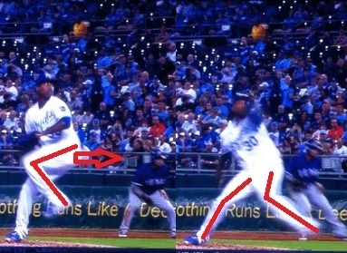
Do you notice how the outside of the stride-foot ankle faces the target as early as possible—and for as long as possible?
Do you also notice when the lead leg starts down toward landing, it remains bent along midline rather than fully extended or swung around into the landing position?
The pitcher shouldn't lean his head and trunk back (or curve his body forward) during the stride; he should maintain good upright posture throughout this sideways movement.
The line of the spine should be vertical even though the head looks toward the target while the body is turned sideways. This will ensure the body moves forward as a single unit and influences force production maximally.
What I have observed in high velocity pitchers is that the weight is held back over a firm posting leg until the lead leg starts downward. The stride foot comes downward a little more than shoulder width apart and slides above the ground to the contact area.
The upper body and the head stay at the top center of the widening triangle of the body. It's important to keep the head positioned over the center of the upper body mass from the start of the movement until landing.
During this step, there is no push off the rubber; the body should drift forward. Then once the stride foot has landed and stabilized the body, the hip flexors will pull of the back knee forward and inward off from the rubber.

Steven's pro tip
Early rotation of the hips during the stride can compromise a pitcher's power production. There are generally two noticeable mechanical faults that occur when this happens:
- First, if a pitcher initially tries to turn his body back toward the outfield in an effort to gain more power before the weight shift, he will lose power. Rotation must occur over the front leg, and not the back leg. Any action that rotates the body before directing it toward the target wastes effort.
- Second, if a pitcher does not maintain flat foot ground contact long enough with his back foot, or if he does not direct his body sideways so the back foot rolls forward along with back hip, the heel may start to lift indicating a premature rotation of the hips.
(Lifting the back heel can also occur if the pitcher swings his lead leg out and around in an arc before landing, instead of keeping the stride foot as close to midline as possible.)

Stride direction
Measuring from the ball of the back foot directly to home plate, the ball of the stride foot should land within 2-3 inches across the midline. This direction helps to keep the front side closed and yet does not overly prevent good hip and trunk isolation.

Stride length
Measuring from the front edge of the rubber to the toe of the stride foot, the length of the stride is usually close to the pitcher’s body height (83±4% of body height).
As previously mentioned, stride length is a good indication of how fast a pitcher is moving away from the rubber building forward momentum.
A long stride is not a problem if the pitcher can get his head and shoulders over the lead leg at the time of ball release.
What is most important, however, is that the pitcher is able to get his head and shoulders positioned over his landing knee at ball release—and braces up for rotation.
Here's another interesting observation about stride length from Randy Sullivan, a great pitching instructor in Florida, that makes a lot of sense:
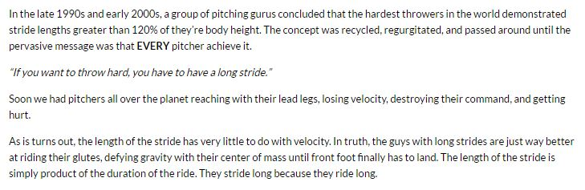
Certainly some good tips about stride length right there.
The take-away is this:
Guys with long strides have the lower-body strength to ride their butt down the mound longer than pitchers with shorter strides. This is something highly-regarded pitching instructor Coach Ron Wolforth, describes as "load while moving forward."
- Many pitchers have problems with the stride. This is recognizable in a short stride landing (< 83% of body height) on a stiff leg and also stride direction. Many young pitchers also stride open across the midline by 2-3 inches since they don't have enough hip flexor and abdominal strength to properly rotate the trunk. This action adds a lot of stress on the arm and shoulder.

Back foot placement
A key element of any pitching delivery is to have the body positioned to the side with the front shoulder and hip pointed at the target before leg drive begins.
This is important: A pitcher should feel the dirt firmly under his back foot and should attempt to keep his entire foot parallel to the rubber as long as possible, as if the foot were semi-glued to the ground.
This will insure that the body will be forced sideways and will not turn or rotate too early over the back leg and hip.

Back leg drive
When leg drive is completed, the back leg should be near full extension just before the stride foot turns to land in contact with the ground (stride foot contact).
If the back leg is still flexed then we know that the pitcher was not moving his body fast enough and not focusing on a strong leg drive, as a sprinter would do in order to get out of the starting blocks faster.

Hand break
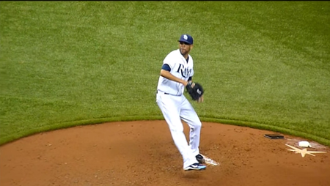
The hands should break apart (separate) between the chest and the belt near the midline and close to the body.
The hands should break down, back and up like a pendulum swing.
Pitchers should aim to break the hands as late as possible after the lead leg starts downward.
This can be accomplished by making sure the pitcher shifts his weight toward the target before he takes the ball out of the glove.
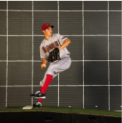
A late hand break forces pitchers to have a fast hand break.
In fact, most of the hardest throwers in the big leagues break their hands 35%-40% into their stride—which is very late compared to amateur pitchers—but also forces them to have to be very fast with the separation of their hands. Nolan Ryan broke his hands almost 50% into his stride.
This is an important timing element because it allows the pitcher's throwing arm to reach the cocked position as late as possible, just before arm acceleration begins.
Most pitchers I've worked with take the ball out of the glove too soon, so the arm gets up into the cocked position too soon.
You don’t want any hesitation of the arm and have it sitting waiting for the pitcher to land. This reduces the amount of elastic energy available to help accelerate the arm because he will end up losing velocity.

Throwing arm action
When the hands separate, the throwing hand should go down, back, then up toward the cocked position in a continuous motion along midline while keeping the fingers on top of the ball.
The throwing arm sequence for most MLB pitchers looks like this:
Down → Back → Up
High velocity pitchers like David Price use one additional technique to keep their throwing arm back and shoulder delayed as long as possible:
When they take the ball out of the glove down, let their arm "lag" until just before landing with a slight lean back of the trunk so that their throwing hand sits next to and slightly behind the back leg to delay it from cocking early.
The throwing arm sequence for high velocity MLB pitchers looks like this:
Down → Back → Lag → Up
This technique allows high velocity pitchers to create exceptional momentum because the throwing arm gets all the body forces being generated from the stride very, very late.
Meanwhile, the glove hand moves forward and upward toward the hitter.
- Many pitchers have problems with the timing and action of the hands breaking apart. The hand breaks backward first instead of downward, disrupting the throwing sequence. They also have problems with the pitching hand staying on top of versus under the ball, causing a short arm (infielders technique) throwing action.

Glove arm action
Good glove arm action helps proper shoulder alignment, trunk arching and flexion, and good trunk rotation. Get the glove arm up early while the throwing arm is still down and back.
There are two basic methods of developing effective glove arm action:
- Fire the glove and lead arm towards the plate and following stride foot contact, violently whip the glove and elbow down and back outside the lead hip. But do not allow the glove to go far behind the lead hip.
- Lead the elbow right at the plate, and following stride foot contact, whip the elbow down and back outside the lead hip.
Both of these methods help to create trunk arching, horizontal trunk rotational, and centrifugal forces of the upper body which generates arm speed and ball velocity.

Steven's pro tip
Don't "tuck" the glove. Many coaches teach young pitchers to tuck the glove, but a study in the Journal of Biomechanics showed a steady glove arm action produces a steady throw and higher velocity.
When you teach to tuck the glove, you are introducing more movement into the throwing motion, producing an inconsistent throw. Instead, stick with the two basic techniques for effective glove arm action:
- Fire the glove, or
- Lead with the elbow

Step 6: Stride foot contact
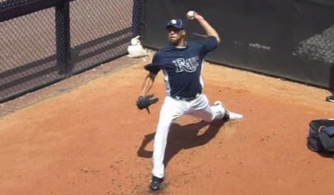
Upon stride foot contact, the pitcher should land flat-footed – not on the heel and certainly not on the toe – locking the front foot to the mound so that it does not move.
Ideally the pitcher's head should be positioned between his two feet. More specifically—and especially in high velocity pitchers—you will notice that the pitcher's nose is behind his belly button.
The pitcher’s lead knee should be positioned over or slightly inside of the ankle. This ensures a strong base of support.
The toes should be angled slightly closed about 10°-20°. And the foot should be closed 2-3 inches across the midline, measuring from the heel of pivot foot to plate.
If the pitcher lands with his lead foot too open, it may cause the knee to continue to move and finish positioned outside of the ankle, which prevents the knee from bracing up and compromising efficient energy transfer to pelvic rotation.
A closed foot and closed toes help keep the front side closed, creating more rotational forces and power that can be applied to a pitch.
- Many pitchers have problems landing hard on the heel, which causes the stride foot to fly open, and the hips and trunk to rotate open too soon. It may also cause the pitcher to get onto a stiff front leg too early, which causes a recoil action or puts him out of balance and alignment during the accretion phase. This negatively affects control and pitch velocity.

Landing leg position
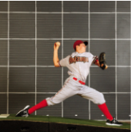
As the pitcher’s lead foot gets closer to landing, the back foot will begin to peel away from the rubber as the leg is extended.
Upon firm stride foot placement, the lead leg is flexed at the knee at about a 40°-45° angle.
As the trunk is rotated to a squared-off throwing position, the lead leg starts to brace up so there is a firm base and a firm front side to rotate up against. As this happens, the back leg simultaneously will extend.

Steven's pro tip
One of the toughest movements for young pitchers to master is good front knee action at and following stride foot contact.
Bracing up with the front leg after front foot plant is absolutely critical for maximizing velocity, according to a 2001 study that looked at the differences between high velocity pitchers and low velocity pitchers:
"Compared to the low velocity group, the high velocity group demonstrated significantly less maximum lead knee flexion angular velocity and significantly greater lead knee extension angular velocity at the instant of ball release."

Back leg position
A common problem observed with many pitchers is the back leg still being flexed upon landing. This could be caused by a less than explosive first movement away from the rubber which results in a shorter stride and less force production. It may also be caused by early rotation when the pitcher does not move his body fully sideways but rotates the pelvis before landing.

Early arm cocking position
Upon stride foot contact, the pitching hand should be approximately cap high (shoulder is abducted approximately 90° with 60° of external rotation) and the hand of a RHP will be slightly closer to third base than the elbow.
The hand and forearm should be extended back slightly further than the elbow, with fingers on top of the ball.

Hips, trunk and shoulder rotation
Upon stride foot landing, the front hip is still closed, but rotates open as the back hip moves forward. The front shoulder stays closed for milliseconds after the hip opens.
The upper body is released like a spring creating tremendous horizontal forces.
Good hip, trunk and shoulder rotation is the result of forward momentum into a long stride. Without forward momentum speed, the hips and trunk would rotate much too slowly for adequate velocity. Besides that there is a very limited distance for the hips and trunk to rotate through that could rival the building of energy from a long stride. Forward momentum is what effects how fast the hips and trunk will rotate.

Preventing early rotation
Since most of a pitcher's power comes from directing the body's forces straight ahead and not from rotational forces, rotating early adversely affects power production. Rotation of the pelvis and trunk after the front foot lands and stabilizes should be a natural movement if the pitcher is directing all his body's momentum at the target. Any action that rotates the body before directing it toward the target wastes effort.
Early rotation generally occurs for two reasons, both of which compromise a pitcher's power production:
- The first happens because of the pitcher initially trying to turn his body back toward the outfield in an effort to gain more power before the weight shift. For proper power production, rotation must occur over the front leg, and not the back leg.
- The second reason is the pitcher does not maintain ground contact long enough with his support foot. If the pitcher does not direct his body sideways so the support foot rolls forward along with its hip, the heel may start to lift. An early support foot lift indicates premature rotation. Lifting the support heel can also occur if the pitcher swings his lead-leg out and around in an arc before landing.
Remember, it's the bracing action of the lead leg and hip that provides the axis of rotation that the pitcher throws against and stops the body from continuing to move forward, allowing the hips, trunk and shoulders to generate tremendous horizontal rotation and centrifugal forces which produce great arm and hand speed, and thus velocity.
- The landing position of the stride foot is vitally important because this is when forces are shifted from the lower body to the upper body. If the pitcher lands softly or does not emphasize this bracing action, then he will lose the opportunity to quickly transfer the energy from the large muscles of the legs to the large muscles of the trunk. This would slow arm speed and reduce velocity. Bracing the leg and hip allows the front hip to act as the axis of rotation of the pelvis as the pelvis and trunk are rotating and squaring itself to face the plate. Many young pitchers allow their lead knee to stay flexed and actually continue to drift forward after foot contact. This prevents good rotational forces and causes a loss of power and velocity. Don't let the landing knee continue to move after landing—brace-up.
With the stride foot planted in position, the pelvis and trunk have a solid base to rotate around. The rotation of the trunk is vital in an efficient transfer of kinetic energy (momentum) up through the body to the pitching arm.

Steven's pro tip
Make sure the stride foot lands slightly to the 3B side (RHP).Research indicates that for every degree away from the midline between home plate and the pitching rubber towards 1B that a RHP plants his foot, a pitcher exerts an extra 46.2 pounds in shoulder anterior forces.
This means that the slightest variation of foot placement could make the difference between a solid pitching performance and putting a pitcher's arm at risk of injury.

Step 7: Arm cocking
At this point, the body is ready to rotate and square off.
RHPs will have the ball cap high and above, with the throwing elbow slightly below the shoulder, and the forearm nearly perpendicular to the ground with the palm of the hand facing the shortstop.
LHPs palm hand faces the second baseman.
The wrist is extended back slightly in a loaded position.
The action of the front (non-throwing) arm during the throwing action will be opposite of the throwing arm in that it travels in a down-forward-and-up motion.
This action efficiently counter balances the body and will provide the needed leverage to effectively assist the throwing shoulder as it accelerates forward in preparation to release toward home plate.

Steven's pro tip
During arm cocking, the pelvis rotates followed by upper trunk rotation. The shoulder externally rotates and the trunk arches (arched back/chest thrusts forward).
Lead arm action is important here.
The key is to have the glove pulled in prior to trunk rotation so that trunk rotation occurs at normal speed. If the glove is left out too far it could slow trunk rotation. This would be similar to what a skater does when doing fast rotations of the entire body...
When the hands are pulled in to the body, the skater is able to turn much faster. The hands out away from the body would slow down rotation.

Step 8: Maximum external rotation
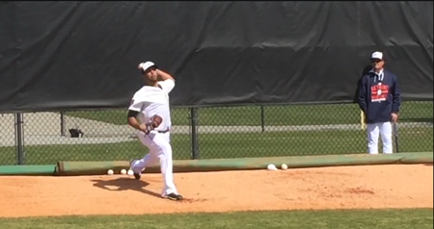
As the hips, trunk and shoulders rotate and square off to the plate, the shoulder externally rotates.
Maximum external rotation (MER)—or "forearm lay back"—is when the throwing forearm is as close as possible to horizontal to the ground during the end of the arm cocking phase and the beginning of the ball acceleration phase of the pitching delivery.
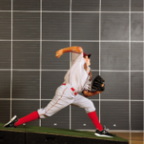
The throwing elbow should be positioned above the non-throwing shoulder during trunk rotation.
The hips and trunk should be facing the target when the throwing arm lays back.
MER in high velocity pitchers is approximately 180°, while elbow flexion is approximately 90°. The greater the external rotation of the throwing shoulder, the higher a pitcher's velocity.
The kinetic chain from the back leg to the hand in MER will demonstrate a reverse “C” position demonstrated in the picture at right.

Steven's pro tip
According to a 2001 study that looked at the differences between high velocity pitchers and low velocity pitchers, the high velocity group had significantly greater shoulder external rotation during the arm-cocking phase compared to the low velocity group.
This implies that for the high velocity group, the throwing shoulder externally rotated through a greater range of motion during the arm cocking phase.
This is important because applying force and accelerating the ball over a greater distance enhances ball velocity.
There's a study that looked into maximum external rotation (MER) a few years ago that compared MER of > 90 mph throwers and 80 mph > throwers. The hard throwing group was able to get their arms back into 179 degrees of rotation whereas the slow group could only get 166.3 degrees.
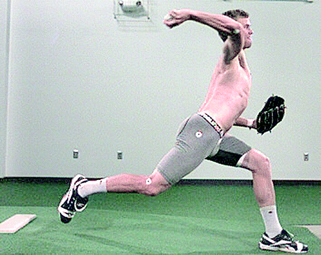
Greater amounts of external rotation allow you to throw harder because you generate more of a stretch reflex in your internal rotators which act like springs allowing your arm to rotate forward at an incredibly fast rate.
Another reason why more external rotation allows you to throw harder is that you are creating a bigger range of motion which means that you have more time to add force -- your muscles take time to build up force so by creating a bigger range of motion you give yourself a little bit of extra time to add an extra mph or two.
According to ASMI:
The greater the maximum external rotation in pitching, the greater distance there is to accelerate the hand forward and consequently the greater the ball velocity.
Max ER is not something that is gained by stretching, unless you're coming back from an injury, or have a deficit of some kind that a Dr. or PT has assessed and is treating you for. MER is a dynamic measurement that is the result of a combination of the rotational velocity of the upper trunk, the amount of rotation at the shoulder joint, the amount of movement of the shoulder blade, and the amount of extension in the upper spine (arching the back).
We've seen too many people out there cranking back on a pitcher's arm, trying to improve his MER, when all they're actually doing is stretching out the joint capsule and creating an unstable shoulder joint. If there isn't a health issue, then you improve ER by improving the efficiency of the pitching mechanics, beginning with the hip/upper trunk separation.

Step 9: Arm acceleration
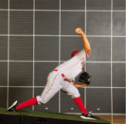
Once the shoulder has reached maximum external rotation, the elbow leads forward and the forearm and hand then fires forward, coming outside the elbow.
The elbow extends followed by shoulder internal rotation as the front knee extends.
The trunk goes from extension to flexion, and the arm and hand accelerate to the release point.

Steven's pro tip
I'm often asked, what is the best arm slot for pitchers? Is a high 3/4 slot better than a low 3/4 slot? Should I tilt my shoulders more?
A simple rule to follow to find the correct arm slot for any pitcher is to make sure his eyes are level at release point. A 2006 study suggests high velocity pitchers ideally have 10° of shoulder tilt.

Step 10: Release
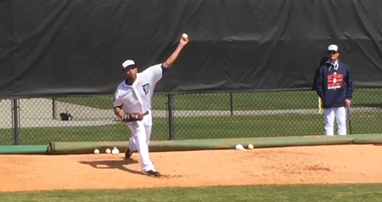
As the hand comes parallel to and crosses the trunk and face, the wrist snaps from an extended back to a neutral position at release.
The fingers are right behind and on top of the ball, and angled outward close to 45°.
The body flexes at the waist over a braced front leg.
Upon release, the hand and arm will naturally pronate as the arm starts to decelerate.

Arm slot
A coach recently asked me:
Should I change a pitcher's arm slot?
When it comes to arm slots, pitchers should do what's natural.
Coaches may be better off focusing on keeping the eyes level and preventing too much body lean and letting the pitcher figure out what arm position feels most natural, which is going to be different for everyone.
Changing arm slot requires a change in posture which can have other consequences (e.g., can cause timing problems, can pull the release point back and raise it up, etc.).
- Many pitchers release the baseball incorrectly in one of two ways: 1) undercutting the ball trying to impart a side spin; the throwing elbow and hand are too low and too far out to the side, or 2) they lack of proper hand speed and lead too much with the elbow and shoulder causing the hand to drag. The latter is usually due to a lack of arm muscle strength as well as the front shoulder flying open too early.
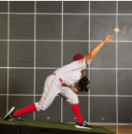
When the ball is released properly, the following actions should be observed:
- Head is directly over the stride leg.
- As the throwing arm moves forward, the throwing elbow should be even or slightly higher than the throwing shoulder.
- Elbow snaps to full extension.
- Wrist is straight and firm behind the ball on all breaking pitches.
- Fingers stay on the top of the ball on all pitches.
- Throwing shoulder, arms, and upper torso extend forward towards home plate.
- Back foot comes off the rubber to complete the weight transfer from the back foot to the front foot.

Foot drag
At the ball release position, many instructors have observed that Nolan Ryan's back foot was dragged as much as 17" away from the rubber.
Dragging the back foot is the result of a pitcher's explosive hip and trunk rotation, which is the result of a pitcher's aggressive speed of movement away from the rubber.
The dragline indicates the location of the spine at release. Optimally this line should end on the imaginary midline leading from the middle of the pitching rubber to the middle of home plate. A lack of a drag indicates lack of proper use of the lead hip in the leg lift and thrust phase of the initial leg lift, in conjunction with minimal use of forward momentum.

Steven's pro tip
At ball release, research indicates that an increase in lead knee extension velocity (bracing up) and an increase in forward trunk tilt (trunk inclination between 32° and 55° towards home plate) both lead to an increase in pitching velocity.

Step 11: Arm deceleration
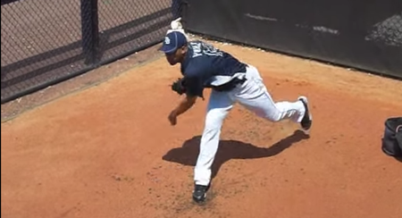
This is the time of great force and stress in the posterior should muscles.
There should be a long smooth continuous arc of deceleration and a transfer of forces onto the major muscle groups of the trunk and legs.
After ball release, the throwing arm continues to internally rotate, leaving the forearm in a pronated position.
Pronation after release happens in all overhead throws – straight throws, curve balls, etc. The arm horizontally adducts in front of the chest. The trunk continues to tilt forward and the back leg steps forward.
A pitcher with an abbreviated deceleration and follow-through may not be using his body to dissipate the energy produced in throwing; this may lead to excessive force in the shoulder and elbow.

Steven's pro tip
During arm deceleration, the shoulder rotates internally and the front knee extension continues. The trunk tilts forward. A pitcher with an abbreviated deceleration and follow-through may not be using his body to dissipate the energy produced in throwing; this may lead to excessive force in the shoulder and elbow.

Step 12: Maximum internal rotation
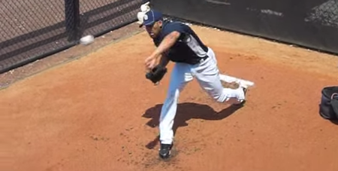
This event marks the end of the arm cocking phase where shoulder and elbow kinetics are at their peak prior to the acceleration of the pitching arm.
It is important to note that sore shoulders usually occur during the deceleration phase of the throwing motion.
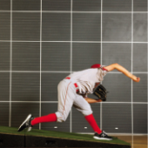
This is due to stronger muscle groups accelerating the arm than decelerating it.
Shoulder stress can be minimized by stressing proper weight transfer and follow-through mechanics during the pitching delivery.

Flat back position
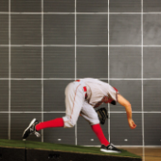
The action of the trunk flexing forward has proven to be a large contributor to pitching velocity.
Once the ball is released the trunk should continue to flex forward parallel to the ground; the lower back flexes to a "flat back" position in preparation for stress absorption necessitated by the deceleration of the throwing arm.
The flexing of the trunk forward will lift the drive or back leg off the ground as a counterbalance.
This insures that the arm takes on less stress.
Make sure he is not upright when he releases the ball, which indicates he is moving too slowly, and that produces a short stride.
Remember, short strides kill velocity and being upright at ball release is more stressful on the arm.

Step 13: Follow-through
Looking at the graph below from a 1983 study, you can see the most shoulder activity at the far right during the follow-through:
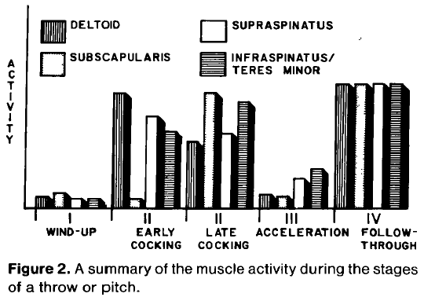
This is why this phase is so critical to prevent injury.
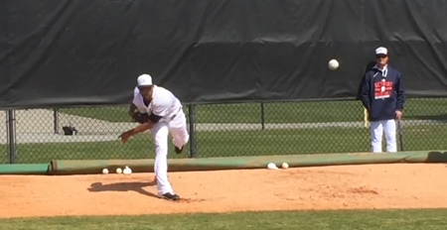
The body weight is brought onto the braced lead leg and the throwing shoulder should come down over the lead leg with the hand and arm finishing down outside the lead leg shin.
Pitchers may need to use a “jump-step” to square off and control the body.
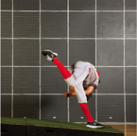
The glove should be brought back in front of the body quickly to protect the pitcher and help field his position.
To save energy, and to help maintain a good visual perception of the plate, the pitcher should just get back up on the mound when receiving the return throw from the catcher.
This allows him to stay in a good pitching rhythm.
- Many youth pitchers have problems with the follow-through, which can be identified by 1) a recoiling action of the throwing arm, or 2) a lack of balance or falling off to one side, or 3) short-arming their throwing arm path of deceleration. These all are generally caused by landing on a stiff leg and/or weak abdominal muscles preventing good forward trunk flexion. Remember, you want to finish in a flat back position.

