GAME SITUATIONS
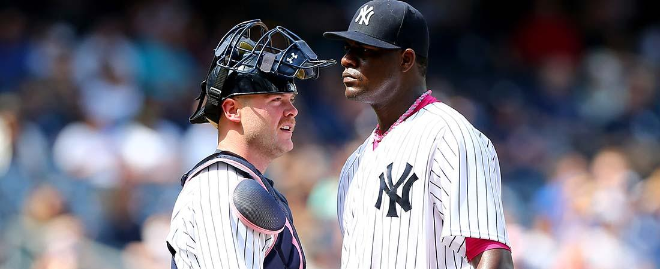
As the "field general," the catcher is involved in just about every defensive play in the game. Below are a variety of situations a good catcher should be prepared for, how to prepare for them and how they should be executed:

GIVING SIGNALS
- Make sure there is no confusion among the catcher, pitcher and middle infielders.
- Signs should be well hidden from opposing coaches and base runners.
- Know all the signs from the coach and communicate them to the pitcher.

BUNTS
- The catcher must call out bunt plays to let the defense know where to throw the ball. The catcher is the only player facing the entire play.
- The offense is giving up an out, make sure to take it!
- When fielding bunts, the catcher should get to the ball quickly and get rid of their mask.
- When approaching the ball, the catcher should be under control with a wide base.
- Whenever possible, the catcher should gather the ball with their chest over the ball.
- Use the glove when the ball is rolling.
- Use your bare hand when the ball is stopped.

BUNTS DOWN THE FIRST BASE LINE
- If the ball is being thrown to first base, the catcher should approach the ball from the left side.
- The catcher should give himself a clear lane to throw when throwing to first base.
- If the ball is being thrown to second or third base, then a direct line to the ball should be taken aggressively.
- Be sure to get to the ball and keep momentum going towards the target.
- Keeping a good arm angle (hand above elbow) creates more accurate throws.

BUNTS DOWN THE THIRD BASE LINE
- If the ball is being thrown to first base, the catcher should approach the ball from the right side. The closer the ball is in line with the pitcher, the more the catcher can circle the ball from the left.
- The catcher should step past the ball with the right foot, reach for the ball with both glove and bare hands, and get the shoulders lined up with the target for an accurate throw.

BLOCKING THE PLATE/TAG PLAYS
- The catcher's left toe should be pointed down the third base line with the heel placed on the front, left corner in foul territory.
- Mask should be left on for protection.
- Catcher should be in a stable, athletic stance and try to catch the ball with two hands.
- Catcher should stay at home plate unless the throw takes them offline.
- Tags should be applied with both hands securing the ball.
- The base runner's path to the plate should be taken away with the shin guards first.
- Using the roll away technique will soften a collision. Stay soft with upper body.

POP UPS
- The catcher should go after every pop up. Communicate with the infielders to call for the ball.
- On pop ups in the general vicinity, the catcher should turn their back to the field and leave enough room for the ball to come back towards the field.
- On plays away from home plate, the catcher should take off their mask. On balls close to the plate, the mask should be thrown when the ball gets to its max height.
- Always try to catch the ball with two hands approximately head high.

FORCE PLAYS / DOUBLE PLAYS
- On force plays or the beginnings of double plays, the catcher should be in an athletic position and always expect a bad throw.
- The catcher should keep their chest square to the throw they are receiving.
- On force outs, the catcher should be on the edge of plate and act like a first baseman if necessary.
- On double plays, the catcher should work their way into the throw and get his momentum moving towards first base.

PITCH OUTS
- The catcher should set up straddling the outside corner of the plate.
- Once the pitcher's arm starts moving toward the plate, the catcher can start their footwork to move them further from the hitter.
- Always expect a bad pitch.
- If a steal attempt was correctly predicted, make a good throw and get the out.

STEPS FOR PITCH OUT FOOTWORK
- Lateral step with the right foot.
- Diagonal step with left foot towards second base.
- Short step with the right foot to line up the throw to second base.
- Complete the footwork with left foot stepping to the target to finish the throw.

RUNDOWNS
- Always try to drive the runner back to third base.
- Run the runner back as hard as you can, but always stay under control.
- Make a good, chest-high throw. No pump fakes.
- Do not leave home plate vacant.

