TIPS ON GAME CALLING
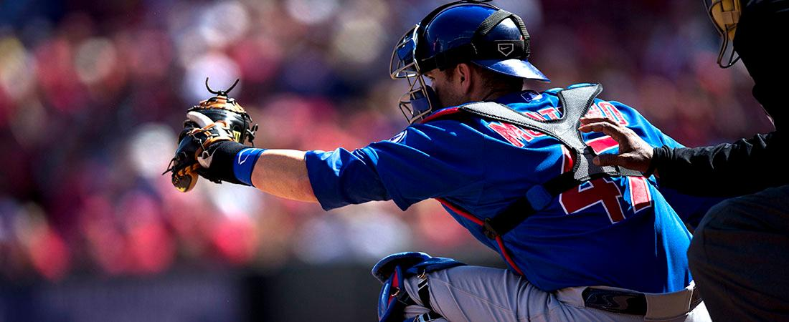
While catching is a physically demanding position, it is also a mentally challenging one as well. Here are a series of tips every catcher can employ to gain an advantage over the opposition and better lead his team:
- Take charge of the game.
  - The catcher is the quarterback - the team will play to the catcher's tempo.
- Know how to handle each pitcher on the team.
  - Know their best pitch for different situations, like double-play situations or two-strike counts.
- Be positive when giving advice.
- Know when to give into the pitcher's choice of pitch.
  - Call time in a big situation and talk with the pitcher.
- Show interest in pitch selection during and after the game.
  - The catcher should be able to go over the pitches thrown with the coach and pitcher after an inning is over.
- The pitching coach and catcher should work hand-in-hand.
- Show emotion when the pitcher makes a great pitch.
- Be smart about pitch selection. Know the best pitches to call for a:
  - First-pitch strike
  - Change-up: how and when?
  - Inside fastball
  - 0-2 count
- Pitch around hot hitters, don't give them anything they can hit well.
- Force the hitter to hit the pitcher's best pitch.
  - Learn opposing hitters

