Game Situation Baseball Drills

10 Fun and Effective Drills to Jumpstart Your Practices
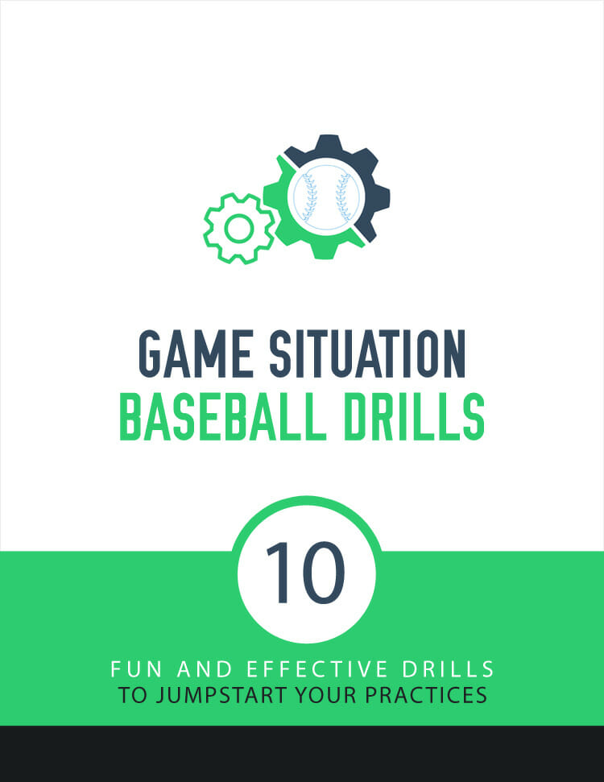

Drill #1: Around the World Throwing

Purpose
The main purpose of this drill is to work on the throws that infielders will be required to make during a game. The catcher will be able to work on throws down to second and third, the middle infielders will work on turning two, and the corner infielders will work on throws home and across the diamond.
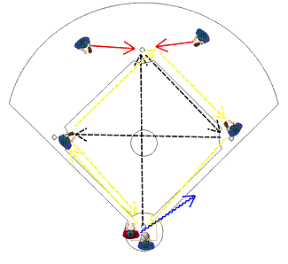

Coaching Tips
- Make sure players are catching the ball with two hands and transitioning smoothly from catching to throwing.
- Players should make sure they touch the base with each and every catch. It’s important that players keep their feet under them and make strong throws.
- The coach should also pay attention to the way the base runner circles the bases. The player should run in a straight line to each base and only curve out to circle each bag about 10-15 fifteen before the bag. This is the shortest distance. (Runners should not make a huge circle around the bases.)

How it Works
- This drill is performed with every infield position manned. When the drill is first run it can be done without base runners. Once the drill is practiced a few times then outfielders can be used for base runners.
- The ball should go “around the world” and back home before the runner makes it all the way around the bases. A game could even be run with a point being awarded to the runners or the infielders depending on who wins.
- The ball starts out with the catcher.
- The catcher throws down to second base where the shortstop catches it, touches the base and throws down to first.
- The first baseman catches the ball while touching first and then throws down to third base.
- The third baseman catches the ball and then throws to second where the second baseman will catch the ball, touch second, and pivot and throw down to first.
- This time the first baseman will catch the ball and throw home.
- The catcher will catch the ball and throw down to third base.
- The third baseman will catch the ball and return the throw back to home.
- If a base runner is used, the catcher should hold onto the ball until the base runner clears past him and then begin the throwing drill by going to second base.

Drill #2: Hit the Cutoff

Purpose
The main purpose of this drill is to work on getting the ball from the outfield into the infield.
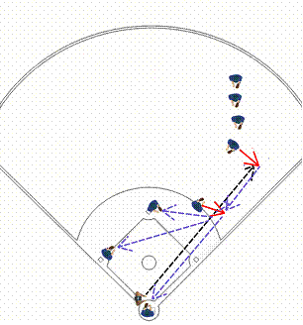

Coaching Tips
- Coaches should look to make sure the outfielder is receiving the ball with two hands. Then the outfielder should use a crow-hop to throw to the cutoff man.
- The cutoff should line-up directly between the ball and home (or the base where the leading runner will be going for).
- The coach should make sure the cutoff man catches with two hands. Preferably the cutoff should already be turning as he catches the ball. Then the cutoff should use the crow-hop and throw to the base that the catcher called.
- The catcher needs to make the call loudly and in plenty of time so the cutoff man knows.

How it Works
- This drill requires a fielder at second, at third, a catcher, a cutoff man, and outfielders.
- The coach will begin the drill by hitting the ball (in the air or on the ground) to the outfielder.
- The outfielder will field the ball and throw the ball on a line to the cutoff man (the ball should be aimed at the cutoff’s head). The cutoff should go out to the outfield grass and line-up between home and the outfielder.
- Once the ball is hit, the coach should tell the catcher where the ball should be thrown. First base is 1, second is 2, third is 3, and home is 4. As the outfielder throws the ball to the cutoff, the catcher recognizes if the cutoff man needs to catch the throw or not.
- If the throw doesn’t need to be caught then the catcher doesn’t yell anything. If the ball needs to be caught or “cut” then the catcher needs to be yell “cut” and then the number of the base.
- For example, if the coach wants the ball thrown to third (because that’s where the runner might be thrown out) then the catcher should yell “cut 3!” If the cutoff doesn’t hear anything then he should just let the ball go. If the catcher does yell “cut” and then a number then the cutoff needs to catch the ball and then throw to the correct base.

Drill #3: Throwing Stations

Purpose
The purpose of this drill is to work on catching and throwing. This is also a good conditioning drill.
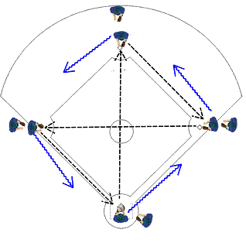

Coaching Tips
- The coach should make sure all players are catching with two hands.
- Players need to transition from catching the ball to throwing the ball smoothly.
- Coaches also need to make sure the players’ footwork is solid. This is a great drill to use to help reinforce how to throw using the crow-hop.

How it Works
- This drill is works best when it’s run with 8-12 players. You might want to run this drill with your position players while you run a separate drill for pitchers.
- This drill begins with a player at each base and at home plate. The ball begins at home plate.
- The player at home fires the ball to second base and then runs to first base.
- The player at second fires the ball to first and then runs to third base.
- The player at first throws the ball to third and then runs to second base.
- The player at third throws home and then runs to home.
- The next players in line continue the drill the same way. The drill continues until the coach stops it.

Drill #4: Throw 'Em Out

Purpose
This drill practices base running and it also helps outfielders practice throwing runners out who try to score and who try to tag to third base.
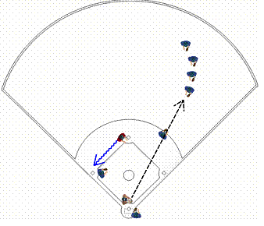

Coaching Tips
- The coach should make sure the cutoff is always hit. The catcher should be calling for the cutoff to cut the ball to third or home.
- The catcher may elect not to have the ball cut at all.
- The coach should make sure the catcher is loud enough and giving the right instructions in time.
- The coach should also make sure the base runner isn’t leaving too early and is running the bases correctly.

How it Works
- For this drill you need outfielders in right field, a catcher, a cutoff, and a few base runners on second base.
- The coach will stand at home plate and hit the ball to the first person in line in right field. The first person in line at second base will be the base runner.
- If the ball is caught by the right fielder then the base runner should tag to third. If the ball drops or is on the ground then the base runner should try to score.
- The cutoff should try to line-up between the right fielder and the catcher or between the right fielder and third base (if it’s a fly ball).
- The outfielder should hit the cutoff and the catcher should call out where the cutoff should throw the ball.

Drill #5: Speed Baserunning

Purpose
This drill is used to help condition players, increase their running speed and improve baserunning technique.
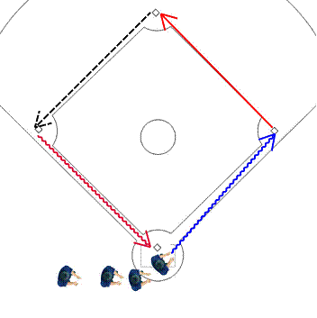

Coaching Tips
- The coach should make sure the cutoff is always hit. The catcher should be calling for the cutoff to cut the ball to third or home.
- The catcher may elect not to have the ball cut at all.
- The coach should make sure the catcher is loud enough and giving the right instructions in time.
- The coach should also make sure the base runner isn’t leaving too early and is running the bases correctly.

How it Works
- All players line-up at home plate. The coach will blow the whistle to signal the first player in line should begin.
- Once the first player gets a third of the way to first then the whistle should be blown and the next player should begin.
- This should continue until all the players are running around the bases.
- The players should change their running style at each base.
- From home to first the players should be kicking their butt. They should be kicking up their heels and kicking their butts with their heels. The goal isn’t to go fast from home to first. The goal is to kick their butt as many times as possible.
- From first to second the players should be running with high knees. They should be kicking their knees up so that their knees come up above their waist. Again, the goal isn’t to go fast from first to second; the goal is to kick up the knees as many times as possible
- From second to third the players should use the “hop/skip.” Players should skip and kick up their knees one leg at a time. As they kick-up their knee they should also bring-up their arm on the same side. For example, as they kick-up their right knee they should be bringing up their right arm.
- From third to home the player should sprint as fast as possible.
- This drill takes a lot of energy if it is run correctly.

Drill #6: Hit to All Fields

Purpose
The purpose of this drill is for hitters to practice hitting to all parts of the field. It develops better bat control and helps with situational hitting.
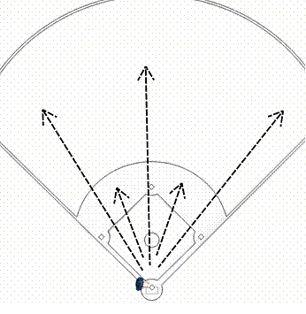

Coaching Tips
- This drill will allow a coach to see how much bat control a hitter has.
- The drill will also help hitters work on their bat control. This will help when a runner needs to be advanced
- The coach should make sure that the hitter isn’t over swinging and is still striding correctly.
- Hitters should not step “in the bucket” when trying to direct the ball. The work should all be done with their hips and upper body.

How it Works
- This drill should first be run with a hitter hitting off a batting tee. Then the drill can be run during batting practice against a live pitcher.
- The hitter should hit the ball to all fields.
- First the hitter should hit fly balls to each field – left, center, and right.
- Then the hitter should hit a groundball to the left side and to the right side of the infield.
- To get multiple hitters practicing this at the same time, set up multiple hitting stations and have each player hit into a net. Mark off targets for left field, center field and right field, and award points to players who can hit each target on demand.

Drill #7: Rapid Fire Double Plays

Purpose
The purpose of this drill is help your middle infielders turn double plays.
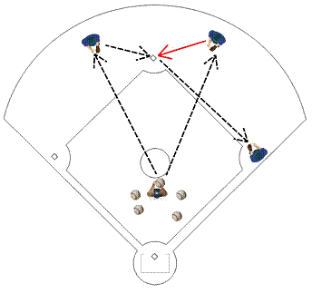

Coaching Tips
- The coach should make sure that the grounders are being taken with two hands and that the fielder is quickly getting the ball out of his glove and throwing to second.
- The player turning the double play should also catch with both hands and make a quick turn.
- Though the fielders will have to range to their left or right to field the grounder, the player should make every effort to get in front of the ball.

How it Works
- For this drill you need a shortstop, a second baseman, and a first baseman. You also need a coach standing between home and the pitching mound.
- The drill will begin with the coach throwing a grounder to the shortstop.
- As the shortstop fields the grounder, the second baseman will move over to second base, and the double play will be turned by the shortstop throwing to the second baseman and the second baseman throwing to first.
- As soon as the second baseman throws to first, the coach should throw a grounder to where the second baseman is normally positioned.
- The second baseman must move over to field the grounder and then start the double play by throwing to the shortstop, who is covering second for the double play
- Once the shortstop throws to first, the coach should throw another grounder to where the shortstop is normally positioned. The drill continues this way for several grounders.

Drill #8: Take the Extra Base

Purpose
This drill helps teach outfielders to get the ball back into the infield quickly and it also teaches base runners to run hard and stretch singles into doubles.
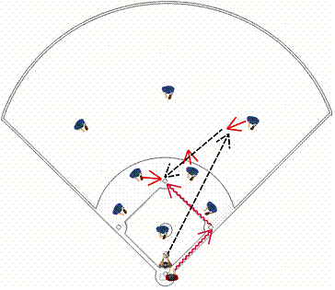

Coaching Tips
- The coach should make sure the base runner is running hard all the way.
- The coach should also make sure that the outfielders are getting in front of the ball (when possible), hitting the cutoff, and making strong throws.
- The coach should make sure the infielders line-up correctly (depending where the ball is hit) and that they receive the ball with two hands and tag out the runner.

How it Works
- This drill is practiced with players in all nine fielding positions. There will also be a line of base runners and a coach with a bat just in front of home plate.
- The coach will hit the ball (or throw the ball) somewhere in the outfield. The runner at home must try to make it to second base or even third base or home. The runner wants to keep going until there is a play at a base or at home.
- The coach should mostly hit singles and the outfield should be able to throw out the runner at second. However, the coach can also hit the ball in the gaps and down the line. The coach can also hit the ball over the outfielders’ heads.
- The runner will learn to run the bases by running hard down to first base. The defense will learn to get the ball back in and throw a runner out without panicking.

Drill #9: Quick Plays

Purpose
This drill will help players get ready for the ball and react quickly to make a play.
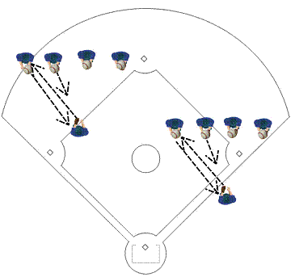

Coaching Tips
- The coach should stress the importance of keeping this drill moving but not throwing the ball too soon.
- The coach should also make sure the one player is getting in ready position each and every time.
- The player should be on his toes, with his knees slightly bent, and his feet shoulder width apart.

How it Works
- This drill begins with sets of four or five players. One player will be facing a line of the other players about twenty feet away. The line of players should stand about five feet apart and they should each have a ball. The one player shouldn’t have a ball.
- Starting on the left, the first player in the line of players will either throw a line drive to the player facing the line or throw a grounder to that player.
- The one player will field the ball and throw it back.
- Then the next player in line will do the same thing and this will continue until the coach blows the whistle and players rotate to the left (with the player on the end of the line becoming the one player and the one player going to the end of the line on the right).
- Before receiving each throw or grounder, the one player must get i ready position to receive the ball

Drill #10: Five Balls Fielding

Purpose
To help players charge a ball and make a quick play. This drill works best with infielders but it can also be run with outfielders.
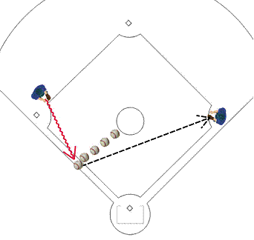

Coaching Tips
- The coach should make sure the player surrounds the ball and fields it cleanly. The player should move quickly but still be under control.
- If the player somehow loses his balance then he should regain that balance before making the throw or he shouldn’t throw the ball at all.
- It should be stressed that it’s a tough play to make and the worst thing that could happen is a bad throw that will give the opponent extra bases.

How it Works
- This drill can be used for any position. One player at a time performs this drill with five balls and a player to throw the ball to. The balls will be placed ahead of the player and the player will have to charge the ball and throw to a designated place.
- For example, for a third baseman you would place five balls between the pitching mound and the third base line. The third baseman would charge the ball that’s farthest on the right, pick-up the ball, and throw it to first.
- This would simulate a bunt or weak hit off the bat. Once the third baseman throws the ball, he should return to his position and then charge the next ball on the right.
- This drill can be run in a similar fashion for any position on the field. Obviously the position of the balls will change and the place where the player must throw the ball might change too. For example, an outfielder might have to hit a cutoff while throwing toward the plate. (This would simulate the outfielder trying to throw a runner out at the plate after a single.)

