YOUNG ARMS AND CURVEBALLS: THE REAL STORY BEHIND IT ALL
Driveline Baseball
https://www.drivelinebaseball.com/2012/03/young-arms-and-curveballs-the-real-story-behind-it-all/#comment-94250
Two weeks ago, the NY Times published an article titled Young Arms and Curveballs: A Scientific Twist. In the article, Bill Pennington interviewed various experts in the field of youth baseball pitching and got mixed answers. Dr. Fleisig of ASMI said his research can’t prove that curveballs are dangerous but cautions that curveballs aren’t necessarily safe either. Dr. Andrews says that fatigue can set in when throwing curveballs (despite fastballs generating higher kinetic loads around the shoulder and elbow; a widely-known fact) and that this might be the mechanism of action for increased injury rates in youth pitchers.
Dr. Kremcheck (well-known for doing bone chip removal surgery and ulnar collateral ligament replacement procedures in elbows) says that there’s definitely a cause-and-effect relationship with curveballs and elbow injuries, even if lab data can’t yet back it up.
So, what’s the real story?
Let this serve as a warning: this article will go into some advanced theoretical details on the positioning of the forearm, shoulder, and elbow in the delivery, as well as in-depth concepts in biomechanics.
If you just want our thoughts on “should youth pitchers throw a curveball”, scroll to the bottom.

PROBLEM #1: CURVEBALLS FOR YOUTH PITCHERS CAN’T BE EXPLAINED IN BITE-SIZED MAINSTREAM MEDIA
As I’ve said before on this blog, the main problem with understanding complex systems (like pitching mechanics) is that… well, complex systems aren’t easy to understand. But the average NY Times reader isn’t going to slog through 50+ research papers on the biomechanics of throwing a baseball to form their own opinion: they want someone like Mr. Pennington to sum it up for them and say something like “Curveballs are weird, man,” and use the stuff in the two-page article at the water cooler of their next Little League meeting.
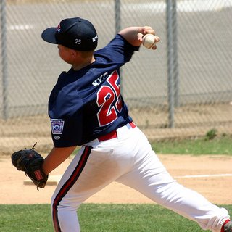
Yeah, I totally understand biomechanics now.
If it were that easy, no one would get hurt throwing baseballs and all pitchers would be over 90 MPH on a regular basis.
We’ve the research on whether curveballs are more stressful than fastballs in our lab. Our findings were similar to what ASMI has found, curveballs result in lower total loads. But when you take velocity into account then curveball becomes more stressful than a fastball! So the answer still isn’t so clear.

PROBLEM #2: DEFINING THE CURVEBALL
What is a curveball, anyway? Well, a curveball is a ball thrown with significant top-spin such that it will break downwards much more sharply than a ball thrown without spin. Coaches generally teach youth pitchers to throw this by setting the forearm in a supinated position and pulling down during arm acceleration with the last knuckles of the index and middle finger pointing at the target. However, things become murky when you watch high-speed video of pitchers releasing the ball – you can tell by the video below that Trevor Bauer does NOT do this:
https://youtu.be/epUoBgtBa9A
Once we can accept that there are many different ways to throw a curveball, what naturally follows is the realization that the mechanics that go into throwing curveballs can vary wildly between pitchers.

PROBLEM #3: KINETICS AND KINEMATICS, ONLY PART OF THE STORY
When ASMI and other labs say that curveballs generate lower amounts of force on the elbow compared to fastballs, they are measuring kinetics around the elbow. (Our biomechanics lab has produced similar results.) However, the kinetic load on the elbow of a baseball pitcher does NOT give you tension loads on the Ulnar Collateral Ligament (UCL) or other tissues – the best a lab can do is give you a weak correlation between the two. Consider that all pitchers throwing over 90 MPH are generating forces on the elbow that would theoretically tear the UCL in cadavers, and you can start to understand that forces between two pitchers (even given similar anatomies) can be distributed in significantly ways.
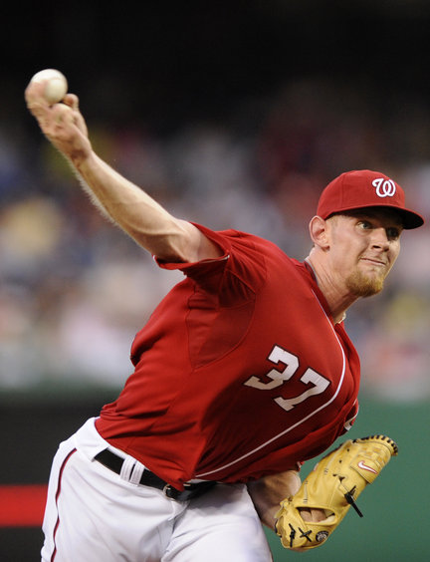
Stephen Strasburg at Ball Release
The positioning of the forearm as it lays back in external rotation matters significantly when we’re talking about how forces are distributed along the elbow, since the muscles in the medial forearm attach directly to the structures in the elbow that are frequently injured (UCL, olecranon, etc).
Additionally, through and at ball release, an actively contracted pronator-flexor mass can reduce ball velocity and increase braking forces, which will reduce kinetics around the elbow joint at possibly critical points in the delivery, perhaps reducing the load the UCL and the distal elbow takes on.

PROBLEM #4: FITNESS, ALWAYS OVERLOOKED
Fitness of the arm and elbow contributes to protecting a pitcher’s elbow and is always the major component that is left out in these articles, because it’s way cooler to talk about pitching mechanics and how you can optimize them for better velocity and durability. However, it’s obvious to anyone that if you have a stronger and better-conditioned arm, you’ll generally suffer less injuries.
We treat pitchers – especially youth pitchers – with kid gloves, telling them to get tons of rest and to not work out very hard. Then you send the kids into pitch where they experience massive forces around the elbow and shoulder, and the treatment is to rest and rest until the next time you pitch.
This is stupid for any number of reasons.
Curveballs require the most stability around the elbow to throw properly, and this fitness factor can be improved through exercises in the weight room and in the pitching tunnel without throwing baseballs at maximal loads. A simple example would be kneeling 2 lb. iron ball tosses into a wall:
https://youtu.be/mU1tboJggTQ
Loss of joint stability can cause further breakdowns in the delivery on the mound or can alter how forces are distributed on the soft tissue of the elbow, so…

CONCLUSION: CURVEBALLS CAN BE MORE RISKY
So do curveballs hurt your arm? Curveballs can absolutely be more risky, but it’s not just a mechanical factor. It’s a multivariate problem that isn’t easy to distill into a single talking point. Pitchers must be strong, well-conditioned in the right areas (endurance is specific to the task, so running a bunch of poles is useless), and have repeatable solid mechanics.

